Listener Registration Form of the ICCIA 2025
ICCIA 2025 will be held at Haikou, China on August 15-17, 2025. Please note that it is essential for all participants to send a completed Registration Form and Payment Proof to iccia@zhconf.ac.cn before July 30, 2025.
- Participant Information
First Name: |  | Family Name:
Position: Professor/ Associate Professor/ Assistant Professor/ Lecturer/ Ph.D Candidate/ Postgraduate/ etc... |  |  | (Photo)
Organization or University:
Research Area：
Special Needs or Dietary Requirements:
Vegetarian □ Muslim □ Other □
City: | State: | Country: | Postcode:
Telephone: | Fax: | Mobile: | Email:
One day tour：Yes □ No □

- Registration Fee by US Dollar***
Items
Listeners | 300 USD/2100 RMB
One Day Tour (optional) | 80 USD/550 RMB

Note:
Listener: Participating in the conference only with neither presentation nor paper publication.
It is suggested that because the conference committee will not deal with air ticket, hotel reservation and visa application, please deal with it in advance.

- Payment Methods
Credit Card Payment Information （Alipay/WeChat）
http://confsys.iconf.org/online-payment/890003173
Please fill in the E-mail and Confirmation Number after paying.
E-mail: | Order Number:

* Cancellation policy:
If the participants request cancellation and refund due to personal reasons, the following refund policy applies.
* 60 days ahead of the conference: 70% of payment refund
* 30-60 days ahead of the conference: 50% of payment refund
* Within 30 days ahead of the conference: no refund
Cancellation and refund request must be made formally via email
* The registration fee cannot be refunded due to any reasons caused by conference participants, such as, visa, etc.
* The organizing committees reserves the right to change the dates and place of the conference due to force majeure.
* The losses thus incurred from the force majeure events shall not be liable and refunds policy shall not apply as well*

* Property Safety: For your property safety, please take good care of your belongings, and valuables should be deposited to the front desk during the conference. If things lost, the conference organizer shall not be responsible for yours!

Please return the Registration Form and Payment Proof to iccia@zhconf.ac.cn before July 30, 2025.

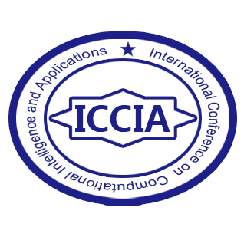
ICCIA 2025
http://www.iccia.org/
Haikou, China

